**README File**

* **Describe the required functionality of the project. Include the screenshots or screencast taken while testing and deploying your dashboard (Step 6) as proof that you have achieved the required functionality.**

The project involves creating an interactive dashboard that allows users to explore and analyze data related to animal shelter outcomes.

Dashboard: The dashboard provides an interface for users to interact with the animal shelter database. It includes features such as filtering by rescue type, displaying a data table of animal records, showing a pie chart of animal breed distribution, and presenting a map with the location of selected animals.

Logo: The dashboard displays the **Grazioso Salvare logo** of the animal shelter organization at the top for branding purposes.

Pie Chart: The pie chart visualizes the distribution of animal breeds within the database. It provides insights into the variety of breeds present in the shelter and their relative proportions.

Map: The map component displays the geographical location of selected animals. Users can click on a row in the data table to view the corresponding location marker on the map.

**Filtered by Water Rescue:**

* 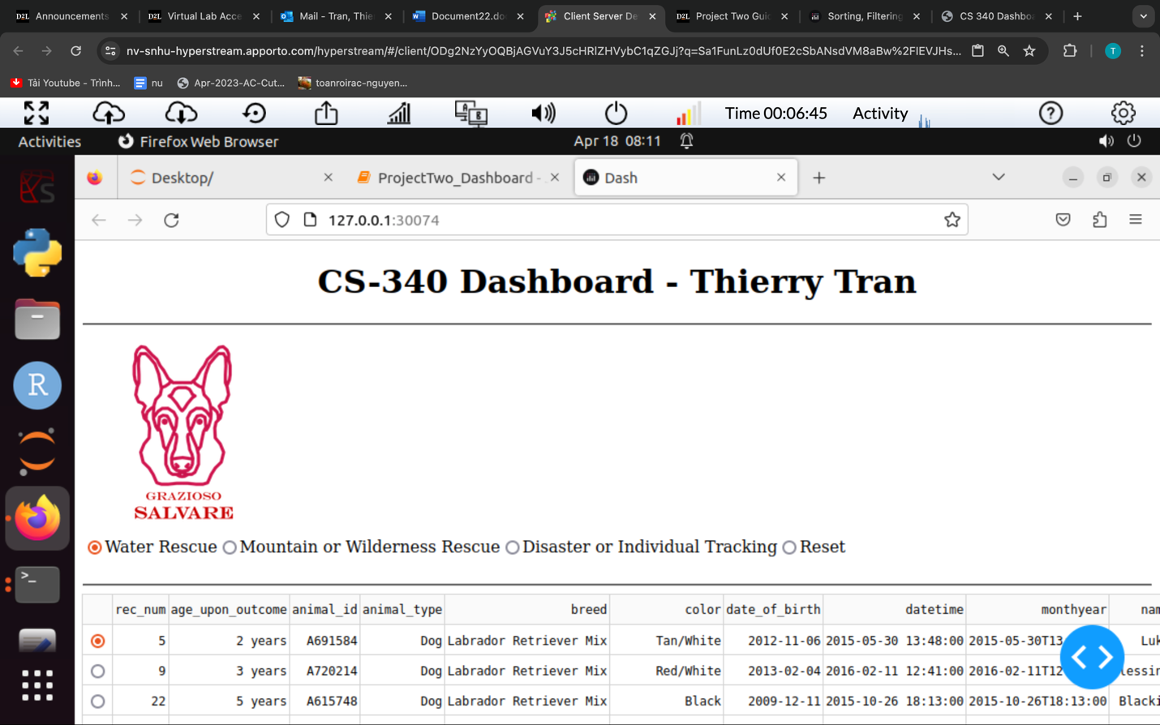
* 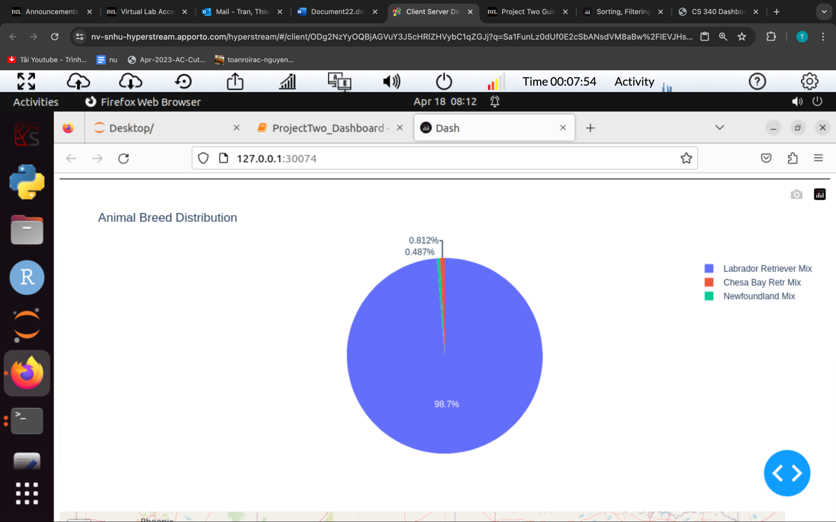
* 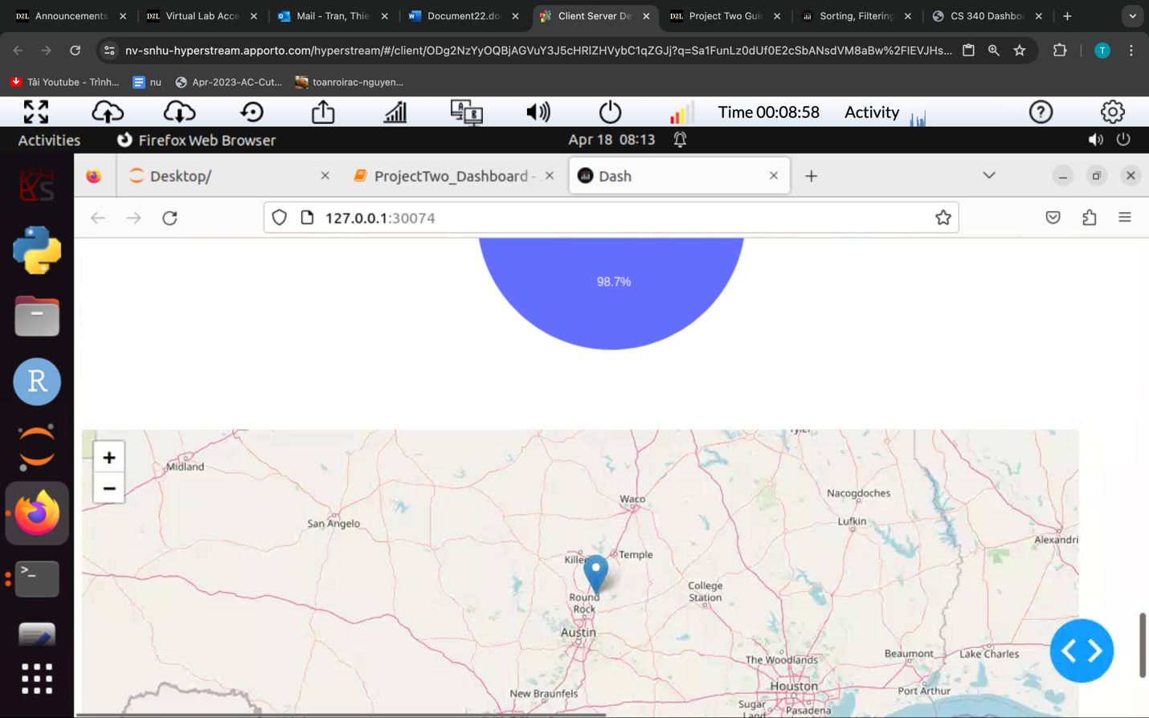

**Filtered by Mountain or Wilderness Rescue:**

* 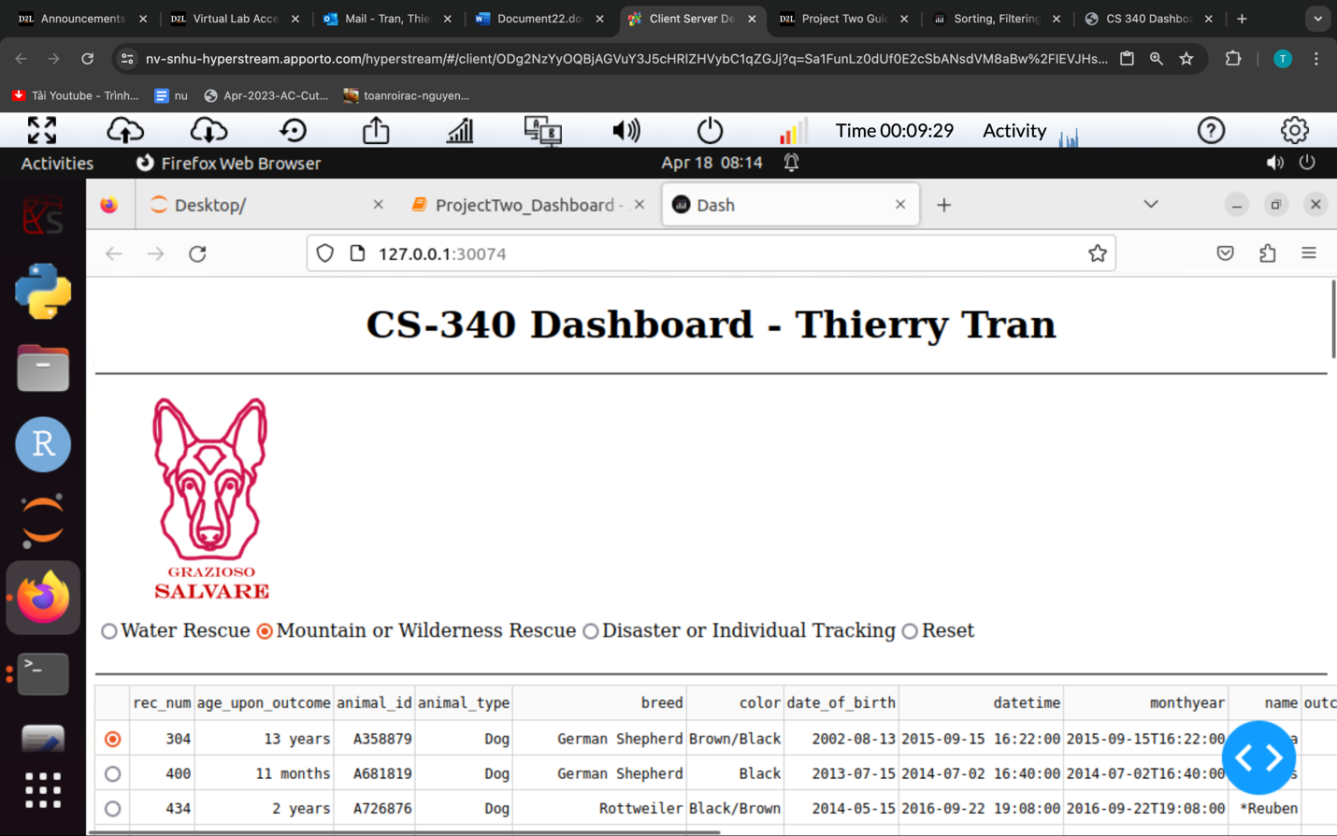
* 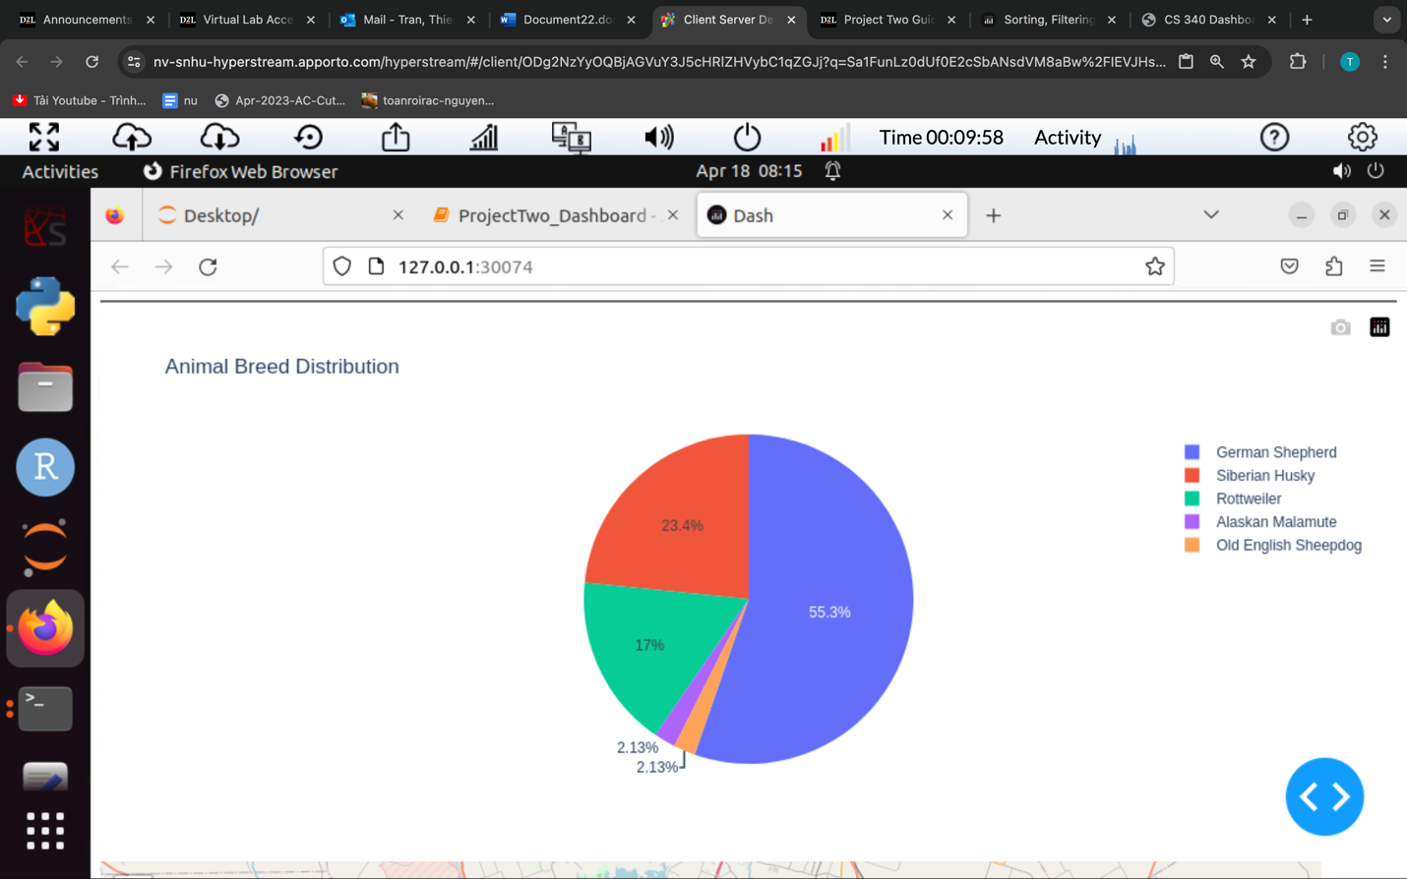
* 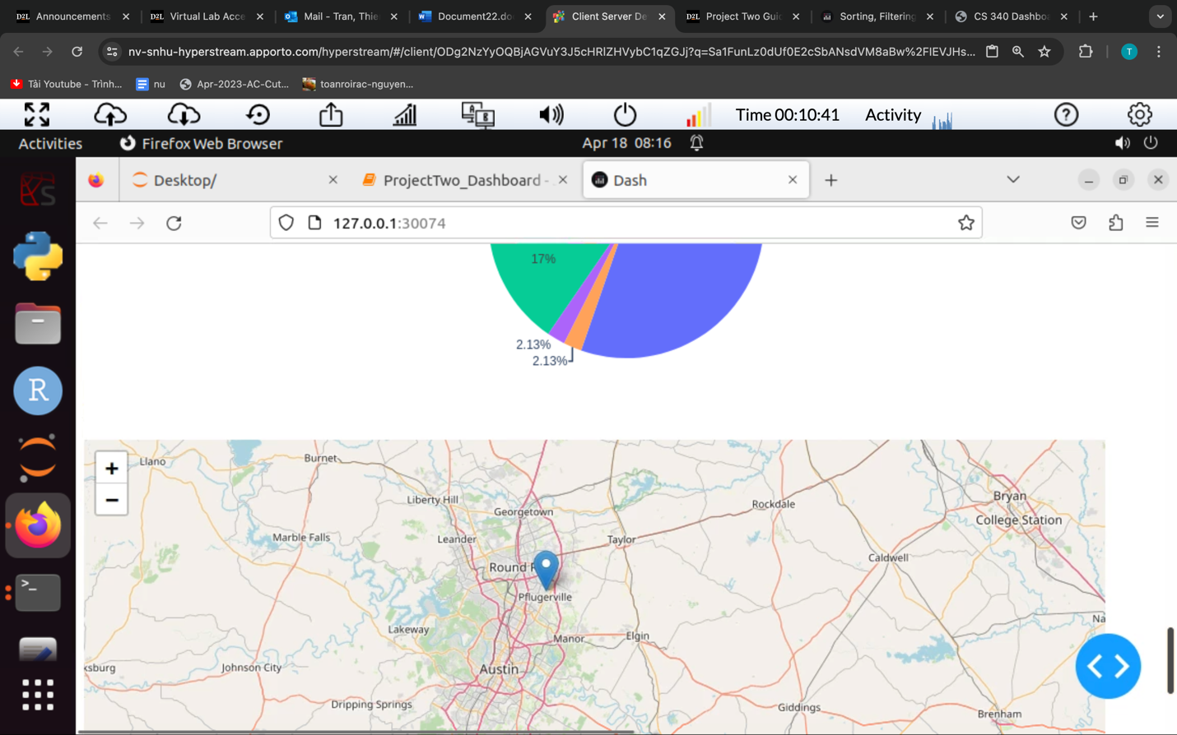

F**iltered by Disaster or Individual Tracking:**

* 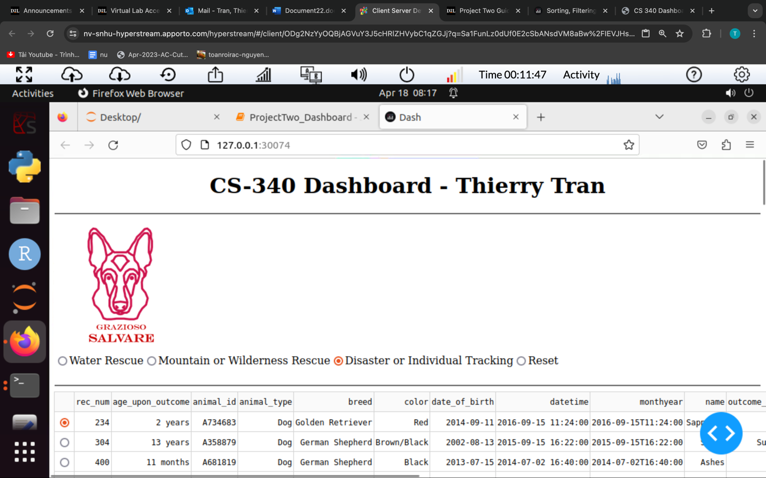
* 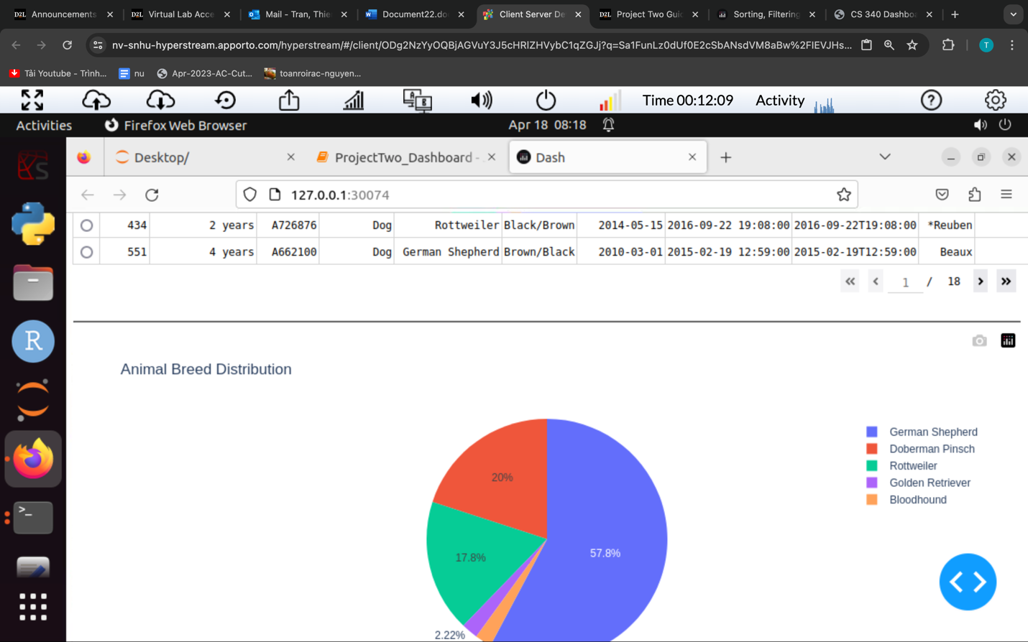
* 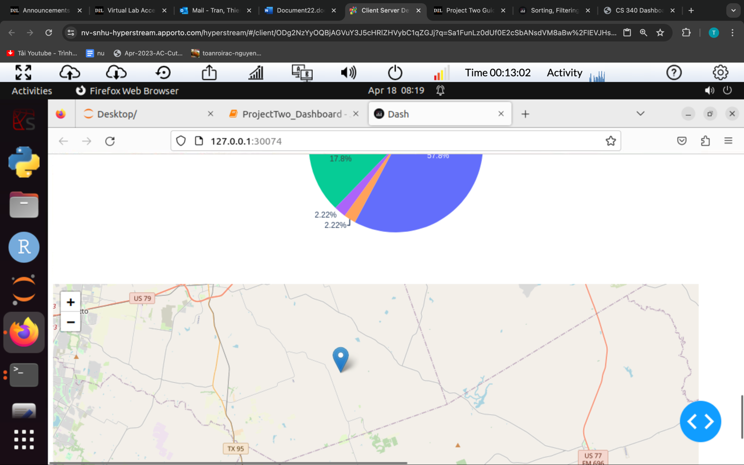

**Filtered by Reset:**

* 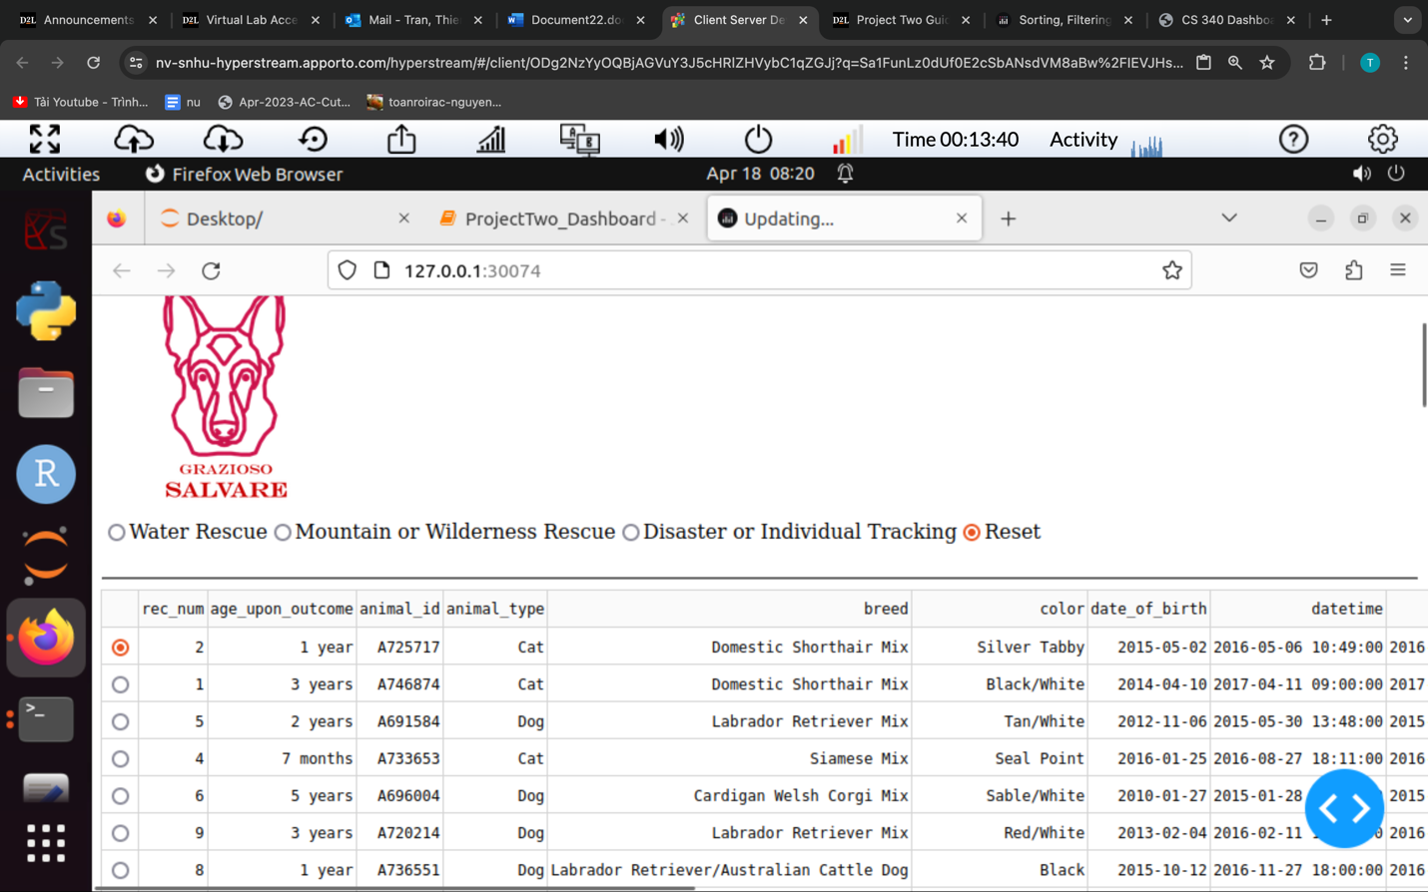
* 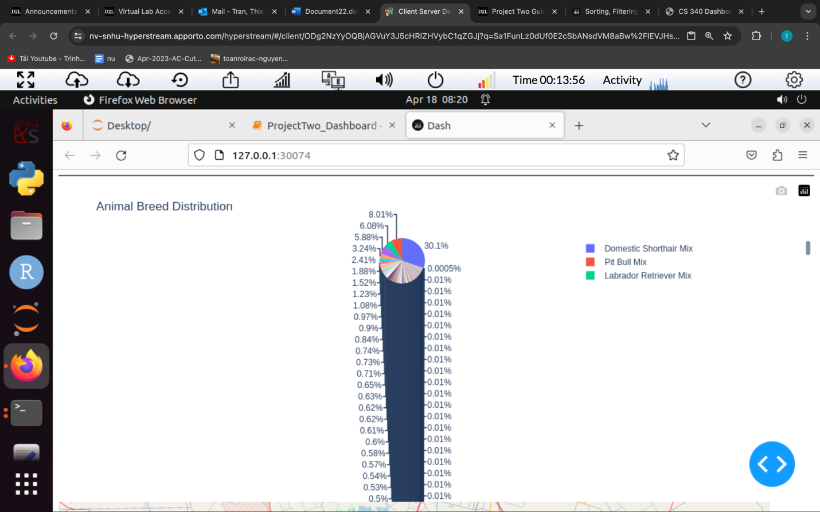
* 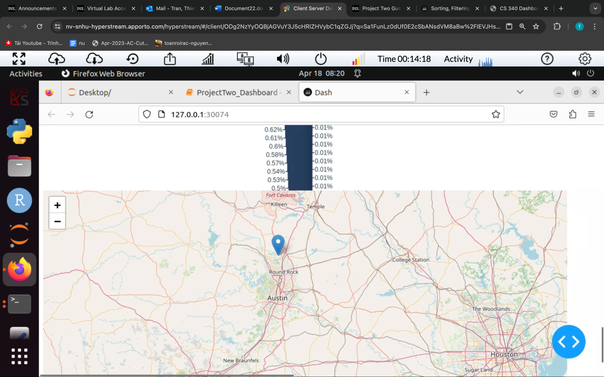
* **Describe the tools used to achieve this functionality and a rationale for why these tools were used.**
* Be sure to explain why MongoDB was used as the model component of the development, including what specific qualities or capabilities it provides for interfacing with Python.

MongoDB served as the model component of the development. We chose MongoDB because it provides a flexible and scalable document-oriented database solution, which is well-suited for storing and managing the animal shelter dataset. Additionally, MongoDB's compatibility with Python via the PyMongo library made it easy to interact with the database directly from our Python code.

* Be sure to explain the Dash framework that provides the view and controller structure for the web application.

The Dash framework was employed to build the web application's view and controller structure. Dash allowed us to create interactive web-based dashboards entirely in Python and with Dash, we could generate dynamic visualizations, such as tables, dashboard and graphs, and incorporate them seamlessly into our dashboard layout.

Be sure to include links to any resources or software applications that were accessed or used.

* + <https://dash.plotly.com/> :

Dash documentation provides guidance on how to use the Dash framework to build interactive web applications with Python. It includes tutorials, user guides, and examples to help developers get started with Dash.

* <https://www.mongodb.com/>

this website provides documentation, tutorials, and resources for learning about MongoDB, including installation guides and usage examples.

* <https://github.com/plotly/jupyter-dash>

This allows creating Dash applications within Jupyter Notebooks. It offers examples and usage instructions for building interactive dashboards directly in Jupyter environment.

* **Explain the steps that were taken to complete the project.**
* Firstly I successfully imported documents from CSV file (aac_shelter_outcomes.csv) into my MongoDB database. This file contains data related to animal shelter outcome.

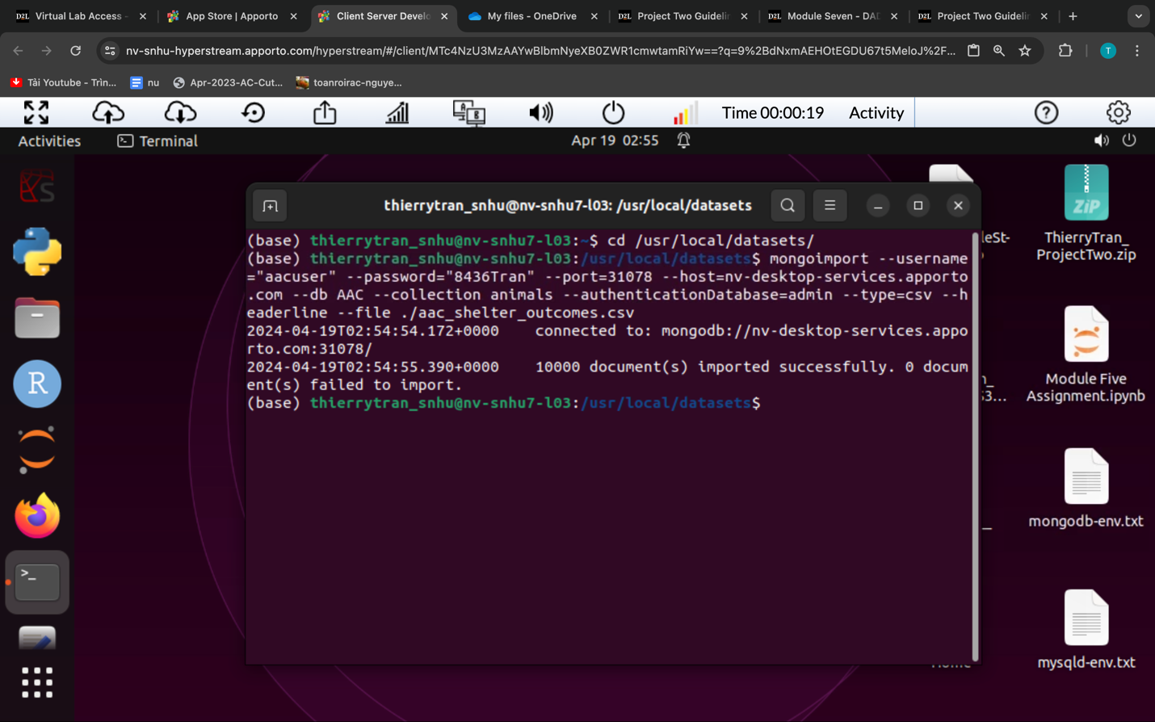

* Secondly, I initialized a connection to the MongoDB database by instantiating the AnimalShelter class from the CRUD Python code (crud_operations.py). I provided the necessary MongoDB credentials, including the username, password, host, port, database name, and collection name. I also retrieved the data from MongoDB using the read() method of the AnimalShelter class, I also set up callback functions to handle user interactions, update the dashboard components dynamically based on user inputs, and ran the JupyterDash app to launch the dashboard.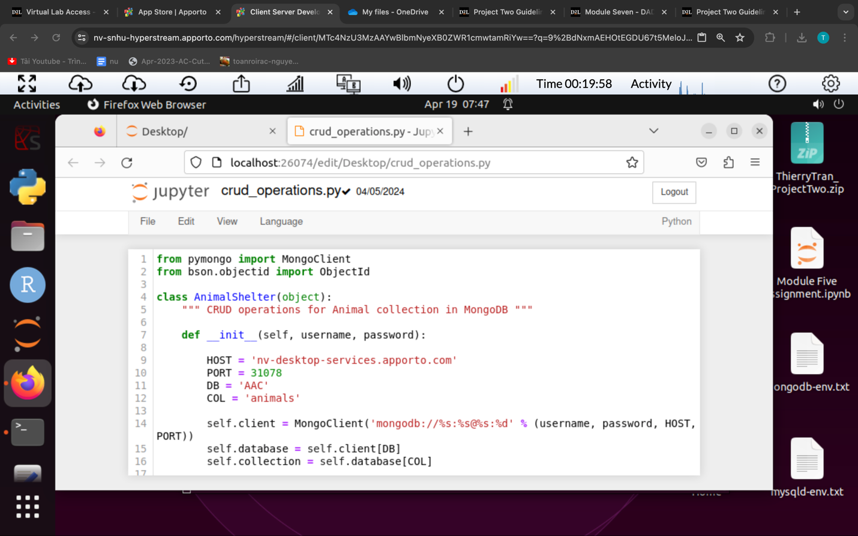
* Then, I set up the layout of the JupyterDash app by defining the structure of the dashboard using HTML components and Dash components like html.Div, html.Hr, html.Img, dcc.RadioItems, dash_table.DataTable, etc. I customized the layout to include the logo, data table, radio buttons for filtering, charts, maps, and other components based on the design requirements, 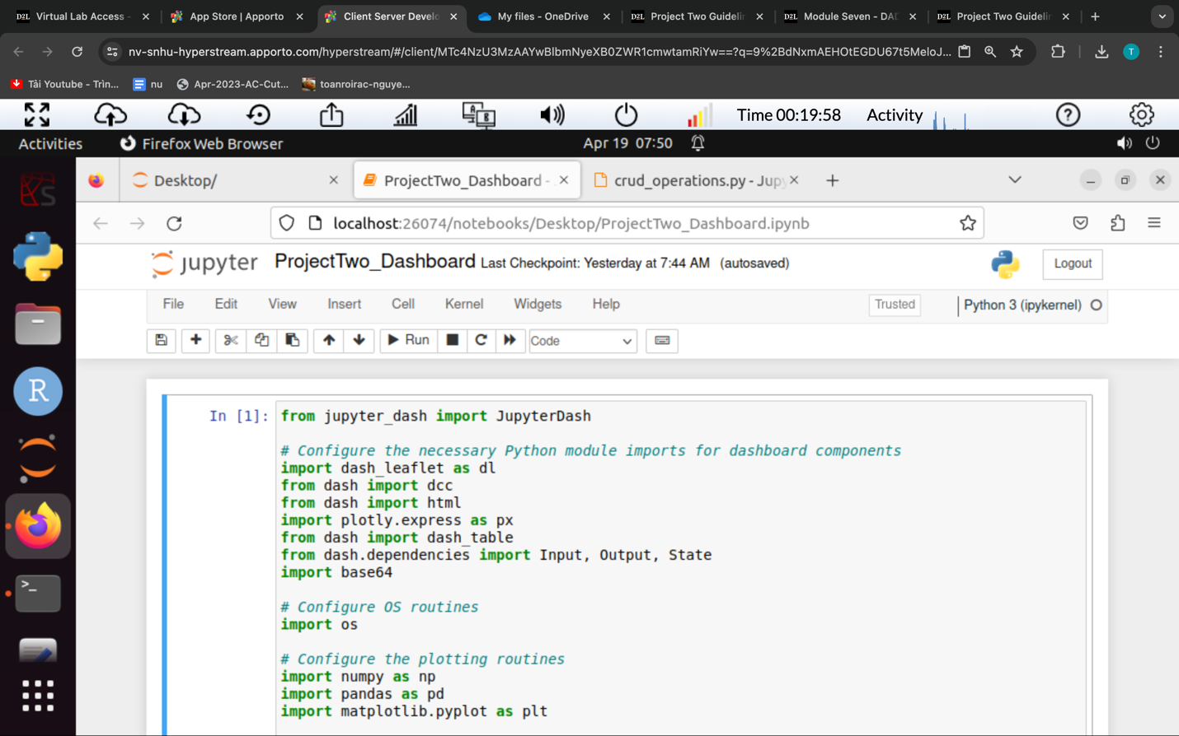
* **Identify any challenges that were encountered and explain how those challenges were overcome.**

I faced few challenges that I were encountered during this project such as

* Dashboard Design: Integrating interactive components like data tables, charts, and maps smoothly into the dashboard was challenging. I tackled this by handling events and callbacks effectively to update components dynamically based on user input.
* Filtering and Data Visualization: Developing logic to filter data based on rescue types and visualize it using pie charts and maps required careful consideration. I ensured efficient and accurate filtering logic by optimizing data structures and processing methods.